A Scale Model of Earth from the Inside Out Name: ________________________
Unit 4 – Models and Dimensions of Earth Date: __________ Block: ________

Lab – A Scale Model of Earth from the Inside Out

Objective: To complete a scaled model of the Earth, by relative thicknesses of each of earth’s layers from its interior (core) all the way out to the thermosphere (where our atmosphere fades to space)
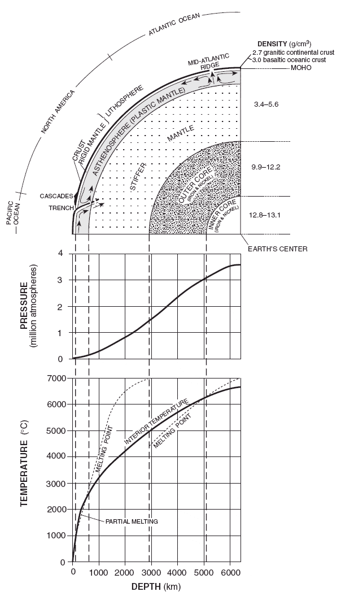
Materials:
80 cm of register tape, colored pencils, meter stick and ruler.

Procedure:
1.Complete Data table 1 (Earth’s interior) and 2 (Earth’s atmosphere), using pg. 10 and 14 of your ESRT.

2. The scale for this model will be 1 centimeter (cm) = 100 kilometers (km). On this scale, the thickness of a pencil line (approximately .1cm) will be equal to 10 km (6.6 miles)! Using the scaled thicknesses of each layer, starting at the inner core, you will measure and label each layer along the register tape, ending with the thermosphere.

- When you are finished marking the scaled thickness of each layer, you will color your layers as the following:
Inner core- red Outer core - orange
Stiffer mantle-yellow Asthenosphere -pink
Crust- brown Troposphere-light blue
Stratosphere-dark blue- Mesosphere-purple
Thermosphere-black and lightly fade this color
Out to space!
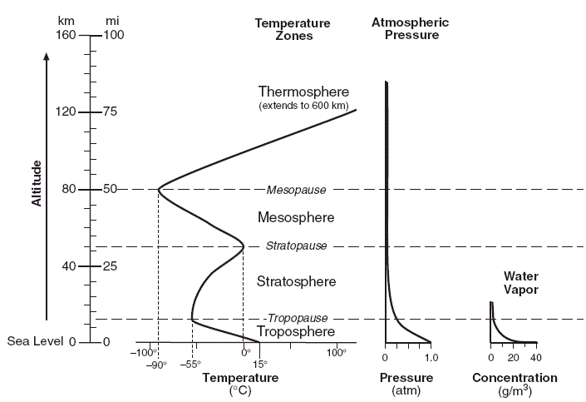

Table 1 – Earth’s Internal Layers

Inferred Properties | Inner Core | Outer Core | Stiffer Mantle | Asthenosphere (plastic mantle) | Lithosphere (crust + upper mantle)
Depth in km. | 6,300-5,200 | 5,200-2,800 | 2,800 – 650 | 650-100 | 100-0
Thickness of layer  (Greatest depth – shallowest depth) | 1,100
Scaled Thickness  in cm (nearest 10th)  (Actual thickness (km)/100) | (1,100/100)  11.0 cm
Density in g/cm  (range) –pg. 10 ESRT |  |  |  | 3.4 - 4.0
Pressure in millions of atmospheres (range) pg. 10 ESRT |  |  |  | 0.1-0.2
Temperature in ºC  (range) pg. 10 ESRT |  | 5,000-6,300
State of matter (solid, liquid, or “plastic”)

Table 2 – Earth’s Atmospheric Layers

Selected Properties | Troposphere | Stratosphere | Mesosphere | Thermosphere
Altitude above sea level in km. | 0-12  Tropopause is at  12 km | 12-50  Stratopause is at  50 km | 50-82  Mesopause is at  82 km | 82-130+  No Thermopause
Thickness of each layer  (Highest altitude – Lowest altitude) | 12 km
Scaled Thickness in cm (nearest 10th)  (Actual thickness /100) | (12km/100)  .1 cm
Temperature Range  in ºC (pg. 14 ESRT) |  |  |  | -90 - 100+
Atmospheric Pressure  Range (atm) (pg. 14 ESRT) |  |  | <0.01 | <0.002
Water Vapor Concentration (g/m)  (pg. 14 ESRT) |  |  | 0 | 0

Discussion Questions – (ANSWER IN COMPLETE SENTENECES)

1. List the 5 internal layers of Earth in order of increasing densities.

2. Explain, using the melting curves from the ESRT pg. 10, why there are two distinct layers of the mantle.

3. Which two segments of the earth make up the lithosphere?

4. What atmospheric variable is used to divide the layers of the atmosphere?

5. Which layer of the atmosphere is the only layer that has weather (cloud formation, precipitation)? WHY?

6. Why does temperature increase in the stratosphere? In answering this, explain why this layer is SO important to life on this planet!

7. Explain why the inner core is inferred to be a solid and the outer core is inferred to a liquid. Include information from your ESRT to justify your answer (melting curves).

8. Using your scaled model (or thicknesses in chart 1), most of the earth by mass, must be composed of which material?

9. The deepest bore hole ever drilled was in Russia over a period of 10 years+, and reached a depth of over 12 km. Which layer of the earth is this in?

10. When you see a weather balloon being launched, it looks as if someone forgot to fill it all the way up. This is done on purpose. When a weather balloon reaches 20 miles above Earth’s surface the volume of the air inside the balloon expands till it bursts. Why?

In which atmospheric layer does the balloon burst?

